Bytecast-amd64

B-Level Specification

Version 1.0

January 20, 2013

CSE 784 – Software Studio

Harsh Sinha

Contents

1. Responsibilities 2
2. Architecture 3
2.1 Detailed Architecture 3
2.1.1 Instruction Parser 4
2.1.1.1 Inputs 5
2.1.1.2 Processing 5
2.1.1.3 Outputs 5
2.1.2 InstructionLexer 5
2.1.2.1 Inputs 5
2.1.2.2 Processing 5
2.1.2.3 Outputs 5
2.1.3 InstructionDecoder 5
2.1.3.1 Inputs 6
2.1.3.2 Processing 6
2.1.3.3 Outputs 6
2.1.4 InstructionObjectFactory 6
2.1.4.1 Inputs 6
2.1.4.2 Processing 6
2.1.4.3 Outputs 6
2.1.5 AMD64InstructionDictionary 7

- Responsibilities
The bytecast-amd64 component is one of the main components of the bytecast project. Responsibilities of this component include:
- Shall use the services of the bytecast-fsys component to get a list of dependencies as well as the byte array of instructions per logical procedure.
- Shall be able to parse the byte array of instructions per procedure into AMD64 assembly instructions.
- Shall convert each parsed instruction into a java class object.
- Shall output a map of procedure vs list of Instruction implementations.

- Architecture
The bytecast-amd64 component will be the starting point in the bytecast project. The diagram depicts the context of operation of the bytecast-amd64:
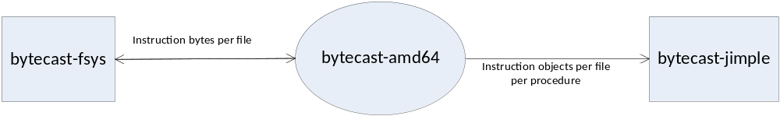

The high-level purpose of bytecast-amd64 is to convert a byte array of Assembly Instructions into meaningful Instruction Class Objects. Given a binary executable file, it shall use the services of the bytecast-fsys to get a set of instruction bytes of the file as well as its dependencies. The bytecast-amd64 will then parse each file’s instruction bytes and create a set of Instruction class objects. This collection of Instruction objects per file will be passed on to the bytecast-jimple component.

  - Detailed Architecture
The following figure depicts the internal architecture of the bytecast-amd64 component:
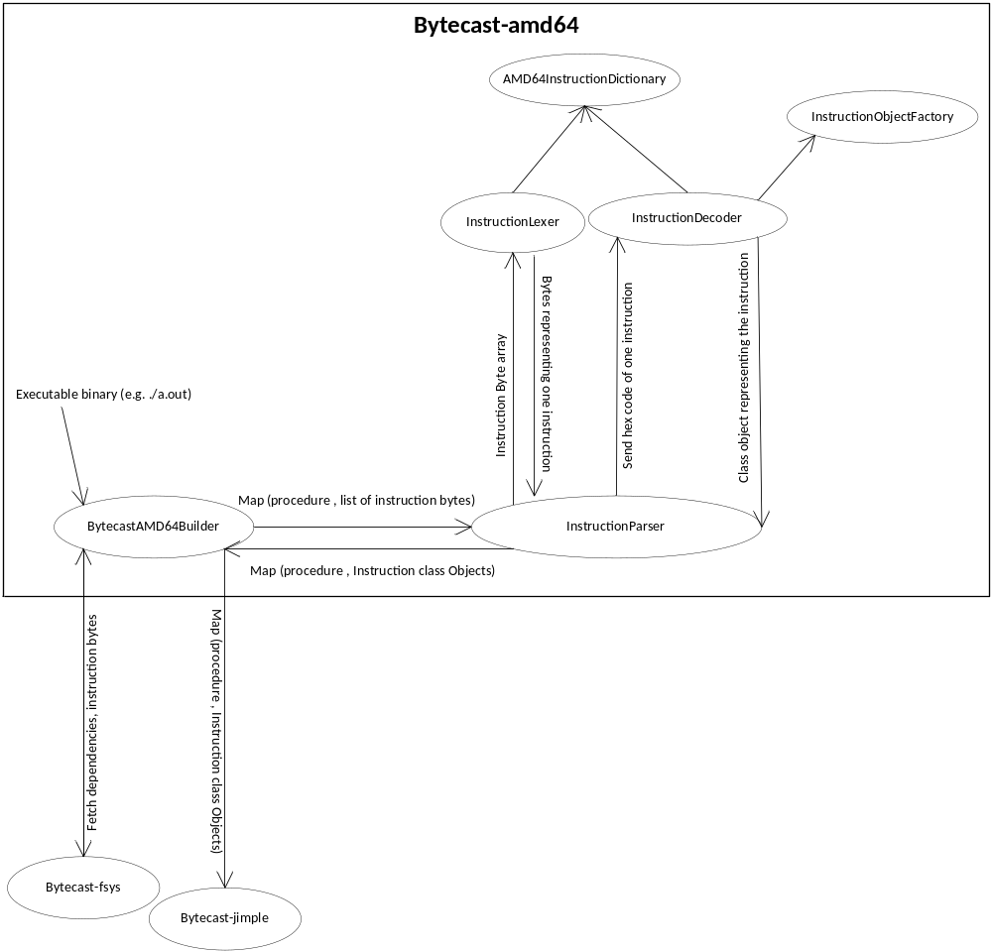
The bytecast-amd64 component has a parser system to convert instruction bytes array into several instruction objects.

    - Instruction Parser
The Instruction Parser is the workhorse of the bytecast-amd64 system and uses a lexer, factory and dictionary to parse instruction byte array to objects.
      - Inputs
- Data Structure that holds byte array of instructions per procedure per file.
      - Processing
The parser takes one procedure of one file at a time and sends the instruction byte array to the InstructionLexer which identifies hex code corresponding to a single instruction. Each single instruction hex code is passed to the InstructionDecoder which decodes the hex code into the instruction and its operands and use the InstructionObjectFactory to create the Instruction class Object.
      - Outputs
- A data structure that holds the Instruction class objects per procedure per file.
- Entry point of the executable

    - InstructionLexer
The InstructionLexer is like a tokenizer that can identify hex codes corresponding to 1 instruction from a byte array containing several instructions.
      - Inputs
- Array of bytes of instructions per file.
      - Processing
The InstructionLexer looks at the byte array and uses an AMD64InstructionDictionary to figure out the combination of hex codes which represent a single token or in this case a single instruction. As it finds a single instruction hex code, it keeps on passing it back to the parser which uses an InstructionDecoder to decode and create objects representing instructions. This collection of instruction objects per file is passed to the bytecast-jimple component.
      - Outputs
- Hex code representing a single instruction

    - InstructionDecoder
The InstructionDecoder shall decode a single instruction represented by a series of hex codes. It identifies the instruction, the number and types of operands etc. If there is a constant value, it converts it into a proper data type like int, float etc.
      - Inputs
- Hex codes representing a single instruction.
      - Processing
The InstructionDecoder takes hex codes representing a single instruction and makes use of the AMD64InstructionDictionary to find out all the information about the instruction i.e. instruction type, number of operands, type of operands, operand values etc. It then uses InstructionObjectFactory to create an object representing this instruction.
      - Outputs
- Java class object representing the instruction

    - InstructionObjectFactory
The InstructionObjectFactory shall be used to create java class objects representing various types of instructions.
      - Inputs
- Constant identifier (could be constant string, int or enum) uniquely identifying an instruction.
- List of Operands
      - Processing
Corresponding to each Instruction which we will be evaluating, there will be 1 java class representing it. All these classes implement a generic interface IInstruction and extend from abstract class AbsInstruction. Depending on the constant identifier passed to the factory, appropriate Instruction implementation class object will be returned.
      - Outputs
- Java class object representing the instruction

    - AMD64InstructionDictionary
The AMD64InstructionDictionary contains a dictionary of hex codes and their corresponding instructions as well as specific registers which will be used as operands. We will have to refer the AMD64 Assembly Instructions specification to build this up.

